Exam Choice  2009  TRIAL HIGHER SCHOOL CERTIFICATE EXAMINATION  Chemistry  General Instructions  - Reading time – 5 minutes  - Working time – 3 hours  - Write using black or blue pen  - Draw diagrams using pencil  - Approved calculators may be used  - Write your student number in the space provided | Student Number  Total marks – 100  Section I Pages 2-18  75 marks  This section has two parts, Part A and Part B  Part A – 15 marks  - Attempt Questions 1-15  - Allow about 30 minutes for this part  Part B – 60 marks  - Attempt Questions 16-27  - Allow about 1 hour and 45 minutes for this part  Section II Pages 19-24  25 marks  - Attempt ONE question from Questions 28-32  - Allow about 45 minutes for this section

Section I
75 marks

Part A – 15 marks
Attempt Questions 1-15
Allow about 30 minutes for this part

Use the multiple-choice answer sheet.

Select the alternative A,B,C or D that best answers the question. Fill in the response oval completely.

Sample: 2 + 4 = (A) 2 (B) 6 (C) 8 (D) 9

A B C D

If you think you have made a mistake, put a cross through the incorrect answer and fill in the new answer.

A B C D

If you change your mind and have crossed out what you consider to be the correct answer, then indicate the correct answer by writing the word correct and drawing an arrow as follows.

A B C D

correct

1. A chemist observed a colour change after adding bromine water, Br₂(aq), to an unknown hydrocarbon.

Which one of the following substances could she have produced in this reaction?

(A) pentane
(B) 2-pentene
(C) 2,3-dibromopentane
(D) 1,3-dibromopentane

2. Which one of the following types of chemist would be most likely to collaborate with a polymer chemist to manufacture a new type of plastic?

(A) an industrial chemist
(B) a biochemist
(C) a forensic chemist
(D) a metallurgical chemist

3. Which name correctly identifies the following piece of equipment?

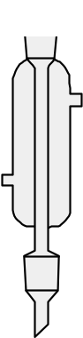

(A) burette
(B) pipette
(C) condenser
(D) refluxer

4. Which one of the following species is the strongest oxidant?

(A) Na⁺
(B) Na
(C) F⁻
(D) F₂

5. Which of the following pairs represent isomers?

(A) ethane and ethene
(B) ozone and oxygen gas
(C) 1-propanol and 2-propanol
(D) oxygen-16 and oxygen-18

6. This question refers to the following substances:

  - H₂CO₃
  - NH₄Cl
  - NaCH₃COO
iv. CH₃COOH

Solutions of which of the substances listed would turn blue litmus red?

(A) (i) only
(B) (i) and (iv)
(C) (i), (ii) and (iv)
(D) (i), (iii) and (iv)

7. Energy content per kg is an important consideration for bushwalkers carrying liquid fuels.

Which one of the following fuels releases the most energy per kg when it undergoes complete combustion?

Alkanol | Molar mass | Heat of combustion (kJ/mol)
ethanol | 46.1 | 1364
butane | 58.1 | 2877
1-propanol | 60.1 | 2021
hexane | 86.2 | 4163

(A) ethanol
(B) butane
(C) 1-propanol
(D) hexane

8. The table below shows the results of 3 tests performed on an unknown compound X.

 | HCl added | H₂SO₄ added | AgNO₃ added
Result | White precipitate | White precipitate | No precipitate

Based on the above results, which of the following could identify compound X?

(A) lead(II) chloride
(B) lead(II) nitrate
(C) barium nitrate
(D) barium chloride

9. A student measures out 100.0 mL of 0.010M hydrochloric acid and labels it ‘A’.

25.0 mL of acid ‘A’ is poured into a second measuring cylinder. 75.0 mL of distilled water is added until the total volume is 100.0 mL. This new solution is labelled ‘B’.

Which one of the following alternatives correctly describes solution B compared to A?

(A) The [H⁺] and the pH will be one-quarter the levels present in Solution A.

(B) The [H⁺] will be one-quarter the level of Solution A but the pH will rise by 4 units.

(C) The [H⁺] will be one third the level of Solution A, but the pH will rise by 3 units.

(D) The [H⁺] will be one-quarter the level present in Solution A and the pH will rise by less than 1.

10. Which of the following is considered a renewable resource?

(A) coal
(B) ethanol
(C) crude oil
(D) uranium-235

11. Which of the following may indicate a fresh water sample has a high degree of hardness?

(A) A lower than normal pH.
(B) A lower than normal BOD.
(C) A higher than normal electrical conductivity.
(D) A higher than normal turbidity.

12. Which of the following correctly matches the name of the scientist with the theory on the nature of acids they proposed?

 | Scientist | Theory of the nature of acids
(A) | Arrhenius | Acids produce H⁺ ions in solution.
(B) | Bronsted | Acids accept electron pairs.
(C) | Davy | Acids contain oxygen.
(D) | Lavoisier | Acids contain hydrogen.

13. Which one of the following is used as a catalyst in the dehydration of ethanol?

(A) dilute H₂SO₄
(B) concentrated H₂SO₄
(C) dilute HCl
(D) concentrated HCl

14. A chemistry class was asked to determine the % of sulfate in lawn fertiliser. According to the packet, the fertiliser contained 36% sulfate by mass.

Each student weighed out 2.00 g of the lawn fertilizer and dissolved it in dilute nitric acid. They added excess 2M barium nitrate solution and noted that a white precipitate formed. They then followed slightly different techniques to obtain dry samples of barium sulfate, which they weighed carefully. Each student repeated the investigation 3 times. Their results are shown below.

Student | Mass of ppt (g)
Student | TRIAL 1 | TRIAL 2 | TRIAL 3 | Average
1 | 1.12 | 1.56 | 1.30 | 1.33
2 | 1.87 | 1.80 | 1.72 | 1.80
3 | 1.75 | 2.15 | 1.46 | 1.79
4 | 1.35 | 1.40 | 1.45 | 1.40

Which student’s results could be described as being the most accurate and reliable?

(A) Student 1.
(B) Student 2.
(C) Student 3.
(D) Student 4.
15. A student added NaOH to HCl in a beaker and used a temperature probe attached to a data logger to monitor the temperature changes over time as the base was added.

Which graph below could represent the results of the experiment?

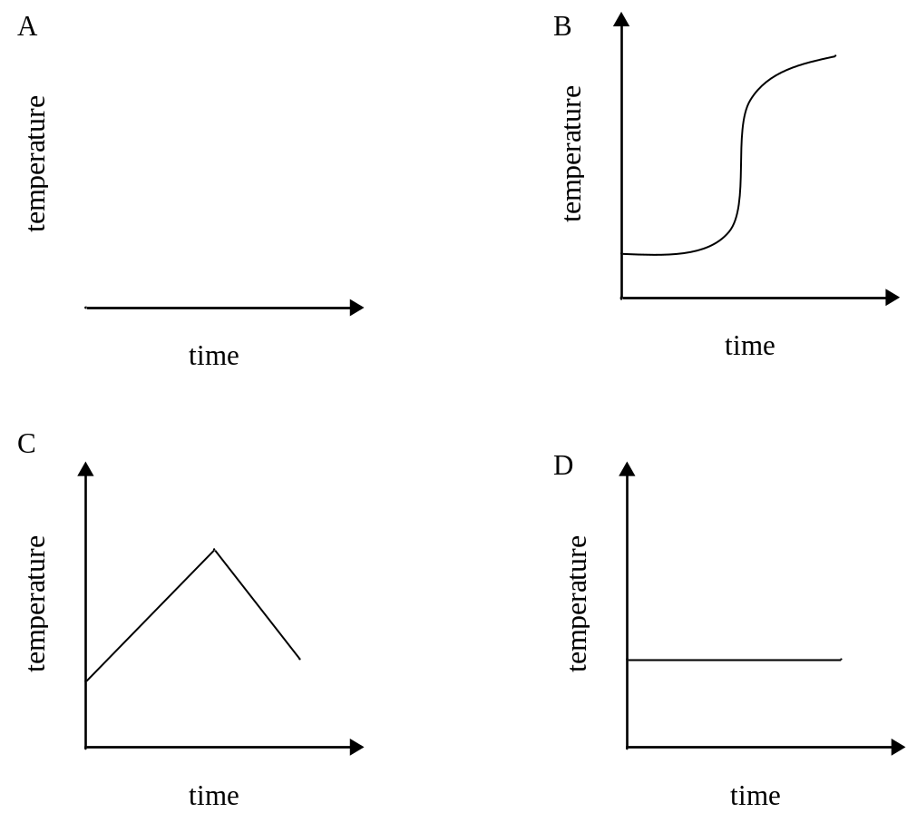

Part B
Attempt questions 16 – 27
Allow about 1 hour and 45 minutes for this part

Answer the questions in the spaces provided.
Show all relevant working in questions involving calculations.

Question 16 (3 marks)  Compare the cracking reactions of C₁₄H₃₀ and C₃H_{8,} and include chemical equations to support your answer.  ………………………………………………………………………………...  ………………………………………………………………………………...  ………………………………………………………………………………...  ………………………………………………………………………………...  Question 17 (4 marks)  Three radioisotopes are shown below:  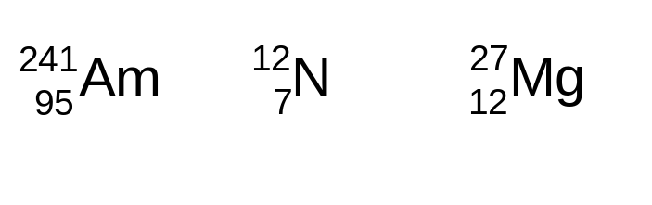  Explain the relationship between the type of radioactive decay emitted, and the reason a nucleus is unstable, using any TWO of the examples above in your answer.  ………………………………………………………………………………...  ………………………………………………………………………………...  ………………………………………………………………………………...  ………………………………………………………………………………...  ………………………………………………………………………………...  ………………………………………………………………………………... | Marks  3  4

Question 18 (5 marks)  Colourless dinitrogen tetroxide decomposes to brown nitrogen dioxide according to the following equation:  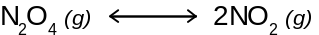  The graph below shows how the moles of N₂O₄ (g) in a 1 L sealed flask changes over time.  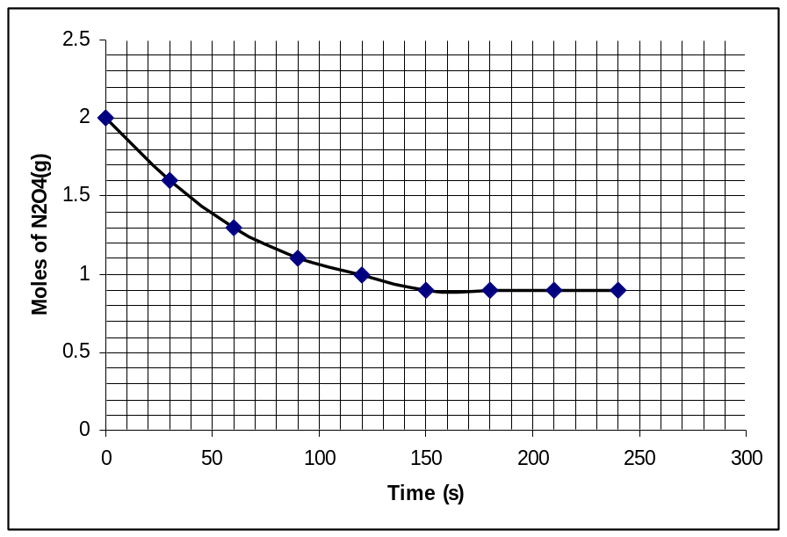  (a) At what time did the system come to a state of equilibrium? Provide a  chemical justification of your answer.  ………………………………………………………………………………...  ………………………………………………………………………………...  (b) Identify how an observer of the flask may infer the system has reached a  state of equilibrium.  ………………………………………………………………………………...  ………………………………………………………………………………...  (c) Use the data in the graph to determine the moles of nitrogen dioxide which  would be present when the system is at equilibrium.  ………………………………………………………………………………...  ………………………………………………………………………………... | Marks  2  1  2

Question 19 (7 marks)  In May 2009, an estimated 4000 Brisbane homes were supplied with water with unacceptably high levels of the fluoride ion. The water they were supplied with contained up to 31 mg/L of fluoride instead of the maximum allowable 1.5 mg/L. The high fluoride levels were due to an error made at a water treatment plant, which was not detected until after the release of the water. Fluoride poisoning may result in a number of adverse health effects, including extreme nausea.  (a) Given that high levels of fluoride can result in adverse health effects,  account for addition of fluoride to the mass water supply.  ………………………………………………………………………………...  ………………………………………………………………………………...  (b) Calculate the moles of fluoride ion present in a 250 mL glass of water  containing the maximum acceptable levels of fluoride.  ………………………………………………………………………………...  ………………………………………………………………………………...  ………………………………………………………………………………...  (c) Accidents such as the one described above illustrate the need for careful  monitoring of the quality of the mass water supply. Describe TWO other  tests which must be carried out on water prior to its release for public  consumption and justify the need for each test.  ………………………………………………………………………………...  ………………………………………………………………………………...  ………………………………………………………………………………...  ………………………………………………………………………………...  ………………………………………………………………………………...  ………………………………………………………………………………...  ………………………………………………………………………………...  ………………………………………………………………………………... | Marks  1  2  4

Question 20 (3 marks)  A 19.4 g sample of glucose was fermented using a sachet of yeast, and 50.0 mL of water in a special light weight conical flask. The flask was placed on an electronic balance, and the mass of the system was monitored over a few days using a data logger.  The experiment was stopped after 96 hours, and the data for mass vs time is shown in the Table below.  (a) Write a balanced equation for fermentation.  ………………………………………………………………………………...  (b) Calculate the mass of glucose remaining in the flask after the reaction.  ………………………………………………………………………………...  ………………………………………………………………………………...  ………………………………………………………………………………...  ………………………………………………………………………………... | Marks  1  2
  Time (hours) | Mass (g) |  | Time (hours) | Mass (g)
  0 | 86.4 |  | 54 | 82.4
  6 | 84.8 |  | 60 | 82.3
  12 | 84.7 |  | 66 | 82.2
  18 | 84.6 |  | 72 | 81.6
  24 | 84.2 |  | 78 | 81.2
  30 | 83.6 |  | 84 | 81.1
  36 | 83.5 |  | 90 | 81.0
  42 | 83.4 |  | 96 | 80.2

Question 21 (5 marks)  A chemistry teacher carried out the following demonstration.  A small mass of sulfur was combusted a in a spoon, burning with a blue flame.  Whilst alight, it was placed into a gas jar to collect the gas produced.  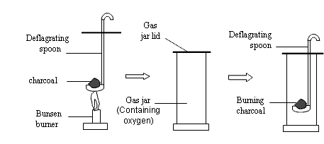  sulfur  burning sulfur  A mist of water was sprayed into the gas jar. Some of the water which fell to the  bottom of the jar was collected and tested with universal indicator. The indicator  turned red.  Evaluate the above demonstration as a model for the formation of environmental acid rain. Include relevant balanced equations in your answer.  ………………………………………………………………………………...  ………………………………………………………………………………...  ………………………………………………………………………………...  ………………………………………………………………………………...  ………………………………………………………………………………...  ………………………………………………………………………………...  ………………………………………………………………………………...  ………………………………………………………………………………... | Marks  5

Question 22 (4 marks)  7.50 g of a pure, monoprotic alkanoic acid (represented as HX) is reacted with  excess Na₂CO₃ producing 2.02 L of dry carbon dioxide gas, measured at 25ºC  and 100 kPa pressure.  (a) Calculate the moles of carbon dioxide gas released by this reaction.  ………………………………………………………………………………...  (b) Use your answer to (a) to calculate the molar mass of the alkanoic acid.  ………………………………………………………………………………...  ………………………………………………………………………………...  ………………………………………………………………………………...  (c) Draw the structural formula of the alkanoic acid.  Question 23 (5 marks)  A galvanic cell was constructed using copper, silver, and appropriate solutions of their salts.  (a) Write redox half reactions for the reaction that occurs in this cell and  calculate the cell voltage.  ………………………………………………………………………………...  ………………………………………………………………………………...  (b) Draw a galvanic cell using one of the redox couples from the answer to (a),  but which would produce a greater voltage than you calculated in (a). | Marks  1  2  1  2  3

Question 24 (6 marks)  (a) Provide a description of Le Chatelier’s Principle.  ………………………………………………………………………………...  ………………………………………………………………………………...  (b) Assess the significance of this principle to the work carried out by Haber in  his efforts to industrially produce ammonia.  ………………………………………………………………………………...  ………………………………………………………………………………...  ………………………………………………………………………………...  ………………………………………………………………………………...  ………………………………………………………………………………...  ………………………………………………………………………………...  ………………………………………………………………………………...  ………………………………………………………………………………...  ………………………………………………………………………………...  ………………………………………………………………………………...  ………………………………………………………………………………...  ………………………………………………………………………………... | Marks  1  5

Question 25 (5 marks)  The table below shows the structural formula of two monomers, labelled A and B.  Using appropriate equations to support your answer, compare the polymerisation reactions of monomers A and B.  ………………………………………………………………………………...  ………………………………………………………………………………...  ………………………………………………………………………………...  ………………………………………………………………………………...  ………………………………………………………………………………...  ………………………………………………………………………………...  ………………………………………………………………………………...  ………………………………………………………………………………...  ………………………………………………………………………………...  ………………………………………………………………………………...  ………………………………………………………………………………...  ………………………………………………………………………………... | Marks  5
  Monomer | Structural formula
  A | 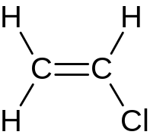
  B | 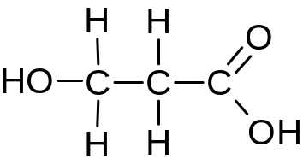

Question 26 (7 marks) | Marks
  A catalytic converter is a piece of technology developed in the 1970s. They are now widely fitted to the exhausts of many cars, as shown in the diagram below.
  Three reactions of a typical catalytic converter:
  - 2NO₂ → 2O₂ + N₂
  - 2CO + O₂ → 2CO₂
  - C₈H₁₈ + 25/2O₂ → 8CO₂ +9H₂O
  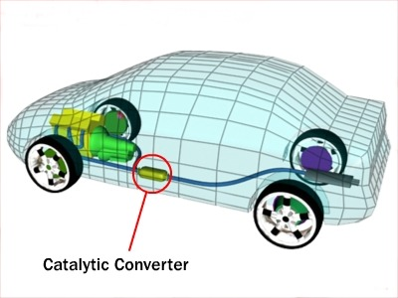

(a) Identify the equation above which would be part of the reduction stage.  Justify your choice by showing oxidation state changes in the equation you  identify.  ………………………………………………………………………………...  ………………………………………………………………………………...  ………………………………………………………………………………...  (b) By referring to the above equations, assess the effect of the use of catalytic  converters on air quality.  ………………………………………………………………………………...  ………………………………………………………………………………...  ………………………………………………………………………………...  ………………………………………………………………………………...  ………………………………………………………………………………...  ………………………………………………………………………………...  ………………………………………………………………………………...  ………………………………………………………………………………... | 2  5

Question 27 (6 marks)  A student used titration methods to calculate the concentration of acetic acid in vinegar by titrating samples of the vinegar against standardised 0.100M sodium hydroxide.  (a) Write a balanced equation for the reaction that takes place during the  titration.  ………………………………………………………………………………...  ………………………………………………………………………………...  (b) Explain, using examples related to this specific titration, how errors in the  way the titration is performed can have significant effects on the accuracy of  the final results of the titration.  ………………………………………………………………………………...  ………………………………………………………………………………...  ………………………………………………………………………………...  ………………………………………………………………………………...  ………………………………………………………………………………...  ………………………………………………………………………………...  ………………………………………………………………………………...  ………………………………………………………………………………...  ………………………………………………………………………………...  ………………………………………………………………………………...  ………………………………………………………………………………...  ………………………………………………………………………………... | Marks  1  5

Section II
Total marks: 25
Attempt ONE question from Questions 28 – 32
Allow about 45 minutes for this Section.

Answer the questions in a writing booklet. Extra writing booklets are available.

Show all relevant working in questions involving calculations.

Pages

Question 28 – Industrial Chemistry……………………………………………….. 20

Question 29 – Shipwrecks, Corrosion and Conservation…………………….…….21

Question 30 – The Biochemistry of Movement……………………………………22

Question 31 – The Chemistry of Art……………………………………………….23

Question 32 – Forensic Chemistry…………………………………………………24

Question 28 - Industrial Chemistry (25 marks)  (a) An important role of chemistry is to provide for our material needs, in an  environmentally and socially viable way.  (i) Identify a shrinking natural resource (which is not a fossil fuel).  (ii) Outline issues associated with the reduction in the availability of this  resource, and identify a current or potential solution.  (iii) The production of synthetic detergents is an example of chemistry  providing an alternative to materials based on natural products.  Compare soaps and synthetic detergents in terms of their structure and  effect in hard water.  (b) Aqueous sodium chloride is used as a starting material for the production of  sodium hydroxide, which occurs by electrolysis.  (i) You have carried out electrolysis of sodium chloride. Outline the  method you used to do this.  (ii) Explain, using equations to support your answer, why different  products are observed when dilute aqueous, concentrated aqueous, and  molten NaCl are electrolysed.  (c) Phosgene, COCl₂, is considered a chemical weapon, and its manufacture is  monitored. It is also an industrially important compound, being useful in the  synthesis of many carbon compounds.  Consider an equilibrium reaction in which it can be formed.  The equilibrium constant for this reaction is 1.2x10³ at 670 ºC.  CO(g) + Cl₂(g) ←→ COCl₂(g) ΔΗ = -108 kJ/mol  (i) Identify the reaction condition which can change the value of K for  this reaction.  (ii) The concentrations of each species in a mixture at 670 ºC were as  follows: [CO] = 0.15M, [Cl₂] = 0.18M, and [COCl₂] = 0.25M.  Deduce whether the system was shifting to the left or the right to  reach equilibrium at the time these measurements were taken.  (iii) Production of sulfuric acid involves an important equilibrium step.  Justify the conditions used to maximize the rate and yield in this step.  (d) Assess the importance of plant location in minimizing the environmental  impacts associated with the Solvay process. Include relevant chemical  equations to support your answer. | Marks  1  2  3  2  4  1  3  3  6

Question 29 - Shipwrecks, Corrosion and Conservation (25 marks)  (a) Oxidation-reduction (or redox) reactions, are the basis of many industrial  and biological processes.  (i) Identify the scientist credited with the first generation of an electric  current due to a redox reaction.  (ii) Outline the major features in the operation of a galvanic cell.  (iii) Compare the work of Volta and Davy in increasing our  understanding of electrochemistry and its applications.  (b) Electrolysis plays an important role in the conservation of objects from  shipwrecks.  (i) Outline a method you used to identify the factors that affect the rate  of electrolysis reactions.  (ii) Explain specific applications of electrolysis in the restoration of  artefacts from shipwrecks.  Support your answer with appropriate half-equations.  (c) Understanding the chemistry of metals and alloys is essential for using and  protecting them appropriately.  (i) Identify the term used to describe metals which form a protective  oxide coating.  (ii) An underground steel pipe can be protected from corrosion by  connection to a sacrificial electrode.  Consider the following reduction potentials:  Fe²⁺ + 2e⁻ → Fe(s) Eº = -0.44 V  Zn²⁺ + 2e⁻ → Zn(s) Eº = -0.76 V  2H₂O(l) + O₂(g) + 4e⁻ → 4OH⁻ (aq) Eº = +0.40 V  Use this data to explain the chemistry of cathodic protection. Include  the overall equation which would occur in this situation.  (iii) Explain how the composition of various types of steel affects their  use, including specific examples in your answer.  (d) Assess the significance of the effect of ocean depth on the rate of corrosion  of shipwrecks. | Marks  1  2  3  2  4  1  3  3  6

Question 30 - The Biochemistry of Movement (25 marks)  (a) Proteins are used as both structural molecules and as enzymes in  metabolism.  (i) Identify the building blocks of proteins.  (ii) Outline the formation and structure of a peptide bond, using a  diagram to illustrate your answer.  (iii) Compare the forces which may contribute to the shape of a protein.  (b) Enzyme activity is an important factor in metabolic reactions, and it is  affected by a number of variables.  (i) Outline the method you used to observe the effect of changing pH  on the activity of an identified enzyme.  (ii) Apply an appropriate model to account for the results you observed  in this investigation. Include a diagram to support your answer.  (c) Fats and carbohydrates are the two main energy sources in our diet.  (i) Identify the end product of metabolism of a typical fatty acid.  (ii) Compare the chemical composition of carbohydrates and fats.  Include suitable diagrams in your answer.  (iii) Design a simple experiment to compare the viscosity of glycerol  and water.  Predict the results of this experiment, referring to the structure of  glycerol.  (d) Different types of exercise require different metabolic processes to use  available fuel. Justify this statement. | Marks  1  2  3  2  4  1  3  3  6

Question 31 - The Chemistry of Art (25 marks)  (a) Humans have used colour to decorate themselves and their surroundings for  thousands of years.  (i) Identify by formula and colour, a chemical used by an ancient  culture in ceremonial self decoration or painting.  (ii) Outline two methods used to colour artworks and objects.  (iii) Compare infra-red and ultra-violet radiation in the analysis of  artworks.  (b) Many transition metals produce different colours depending on their  chemical environment.  (i) You have investigated the different colours of a transition metal in  different oxidation states. Outline the method you used to do this.  (ii) Explain why different colours occur in transition metal complexes,  referring to specific examples to illustrate your answer.  (c) Coordination complexes are important in industry, medicine and scientific  research. For example, vanadium, manganese, iron, nickel and copper all  play crucial biological roles as part of proteins in various organisms.  (i) Identify the block in the Periodic Table to which transition metals  belong.  (ii) Using a structural diagram to illustrate your answer, describe the  bonding in the hydrated copper(II) ion.  (iii) Discuss the use of models in understanding complexes containing  chelating ligands. Include a specific example in your answer.  (d) Assess the contributions of Bohr and Pauli to our understanding of the  electronic structure of atoms and relate their work to the organization of  elements in the Periodic Table. | Marks  1  2  3  2  4  1  3  3  6

Question 32 - Forensic Chemistry (25 marks)  (a) Chemical analysis is fundamental to the work of forensic chemists and some  techniques are particularly suited to analysis of organic compounds.  (i) Identify a reagent that could be used to distinguish pentane from  1-pentanol  (ii) Outline, using structural diagrams, the formation of a peptide bond,  and label the functional groups in the resulting dipeptide.  (iii) Describe how a sample can be identified using mass spectroscopy.  (b) Animals and plants produce different carbohydrate polymers from simple  sugars, which can be of use in identifying the origins of a sample being  analysed.  (i) Outline the method you used, and the results you obtained, when  distinguishing between a reducing and non-reducing sugar.  (ii) Explain the formation of disaccharides and polysaccharides, and  compare the origin, structure and function of cellulose, starch and  glycogen.  Include appropriate diagrams in your answer.  (c) Forensic analysis, for example of DNA and protein samples, requires not  only an understanding of the chemistry of the substances being analysed, but  also of the ethical issues involved.  (i) Identify two functions of proteins.  (ii) Outline the structure of double stranded DNA.  Include a labelled diagram in your answer.  (iii) Describe the uses of DNA in forensic analysis, and outline the  associated ethical issues.  (d) Explain why the emission spectra of elements are unique sets of lines, and  assess their role in forensic chemistry. | Marks  1  2  3  2  4  1  3  3  6

